* **Create the virtuval harddisk and allocate the storage using vm ware workstation.**

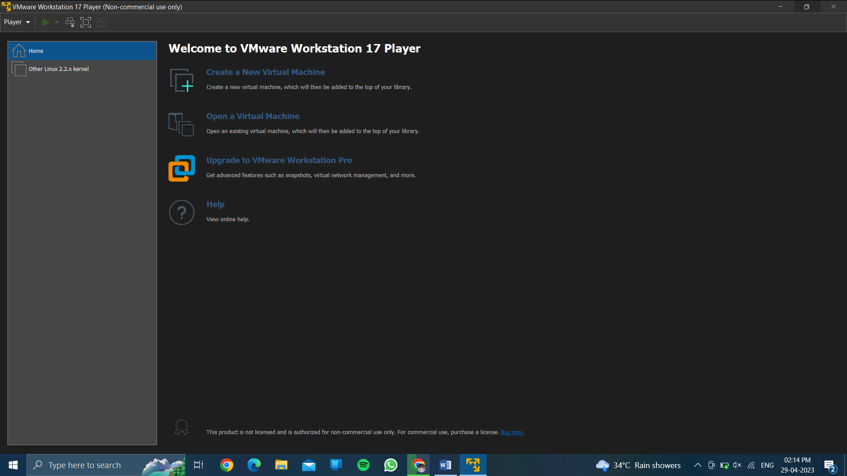

* **Tap on create a new virtual machine.**

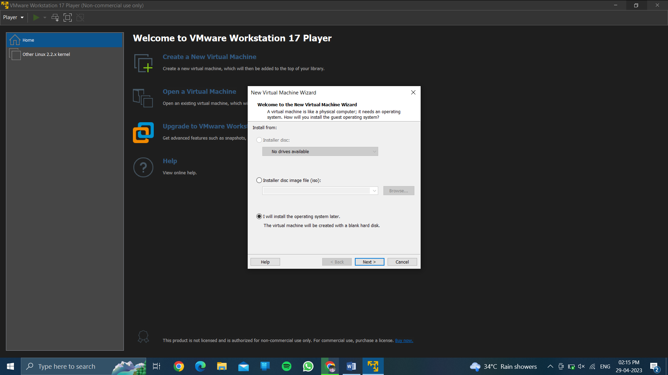

* **Choose i will install the os later.**

**Then click on next…**

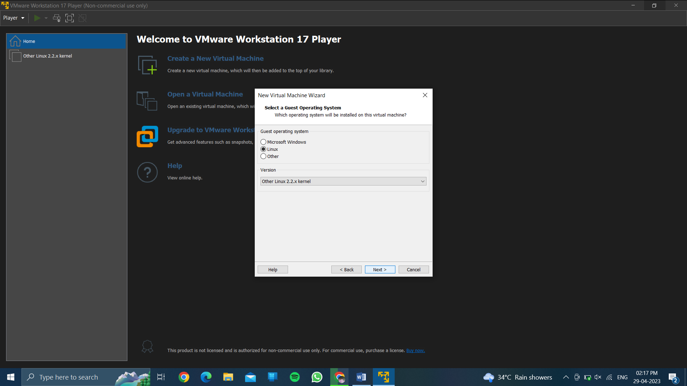

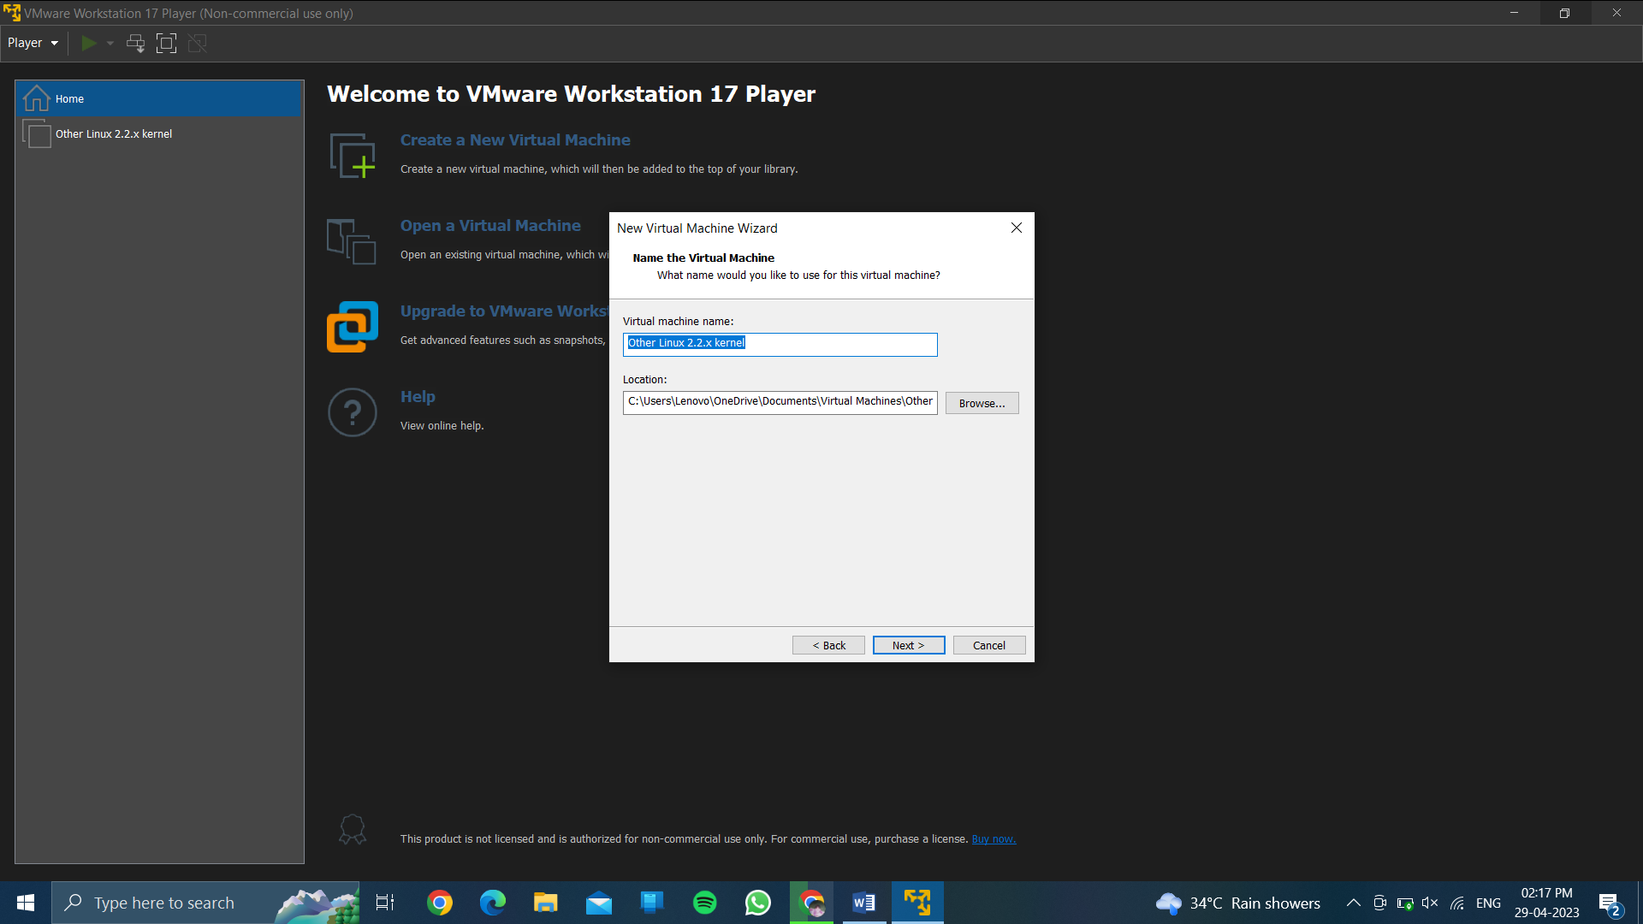

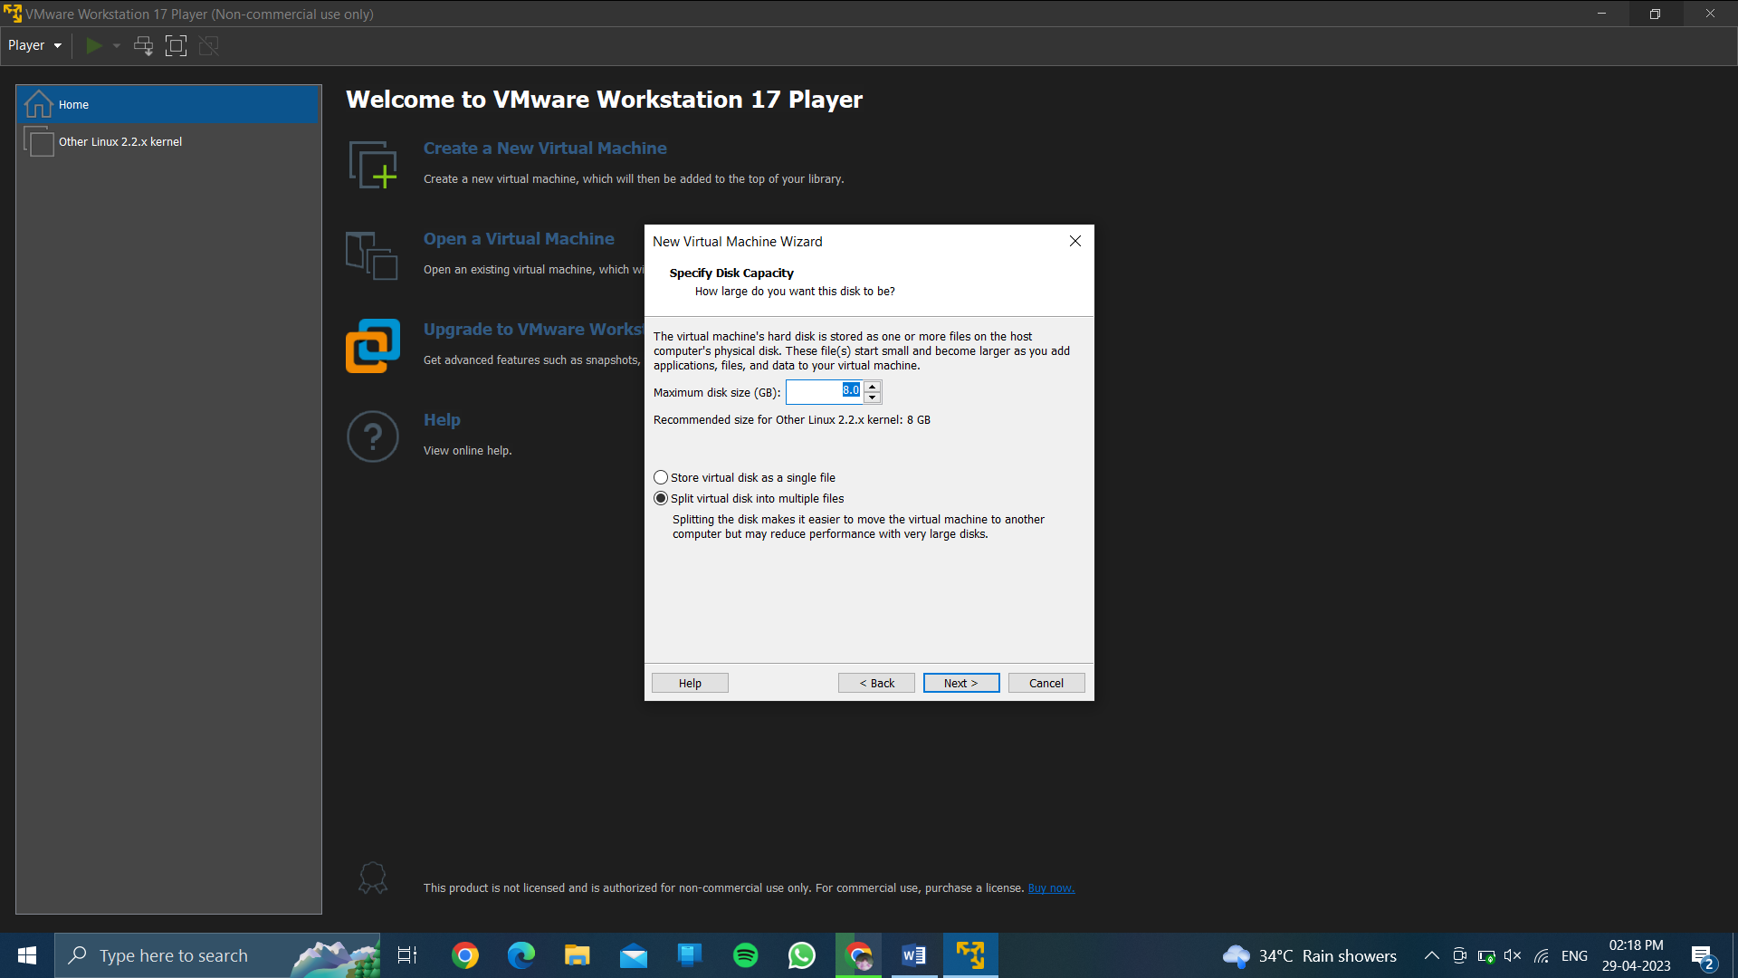

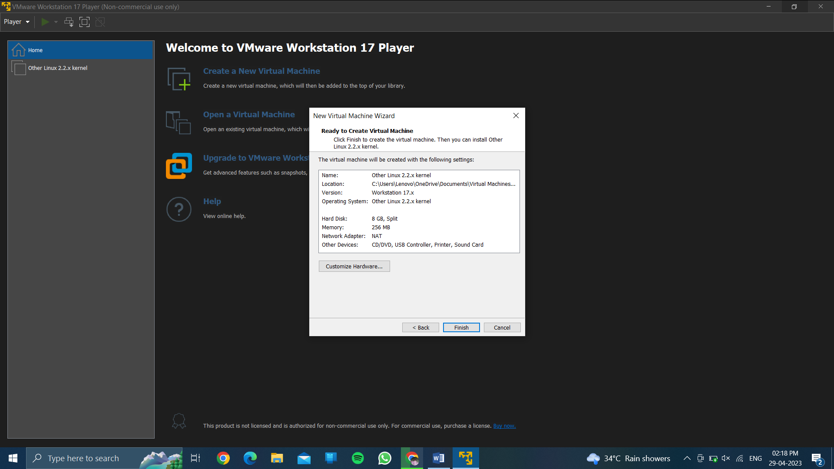

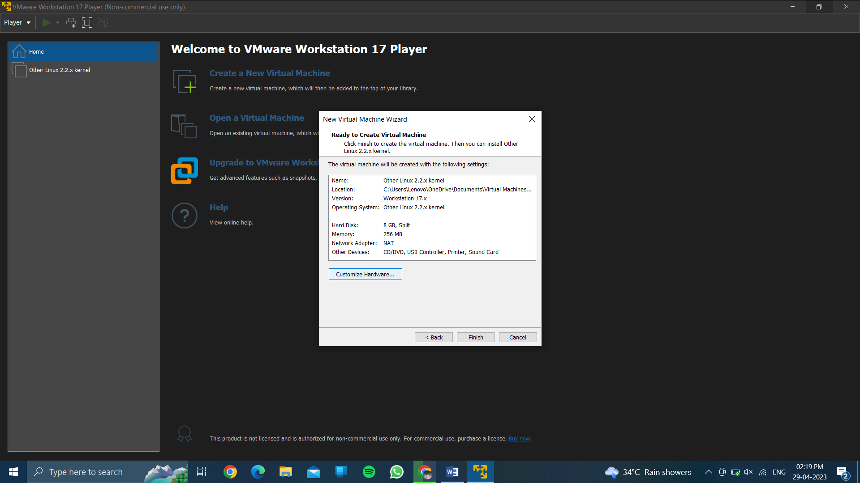

* **Then click on finish**

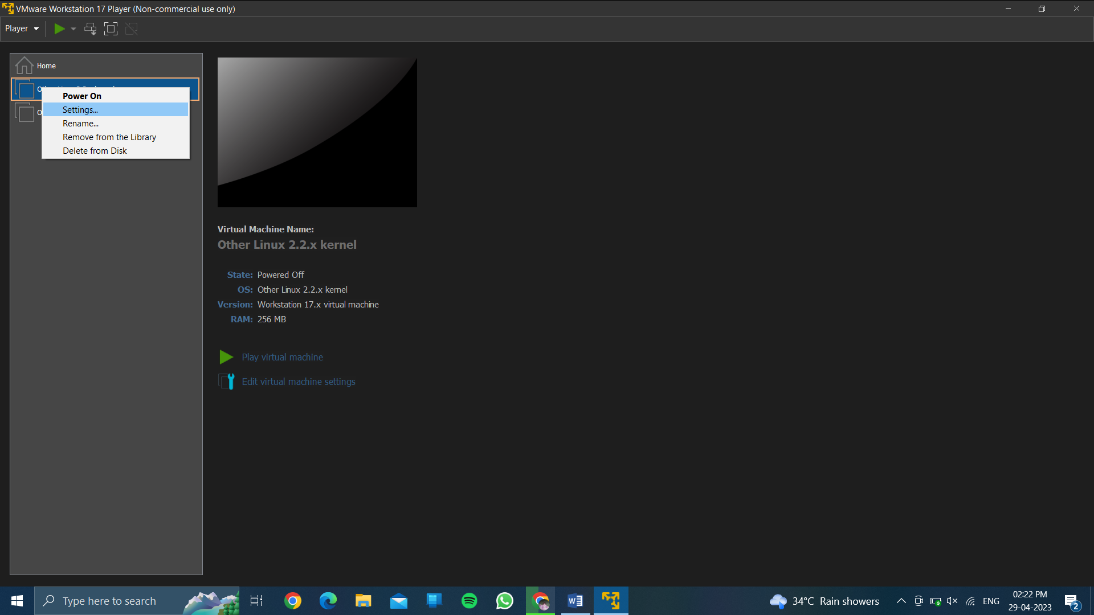

* **Then choose settings..**

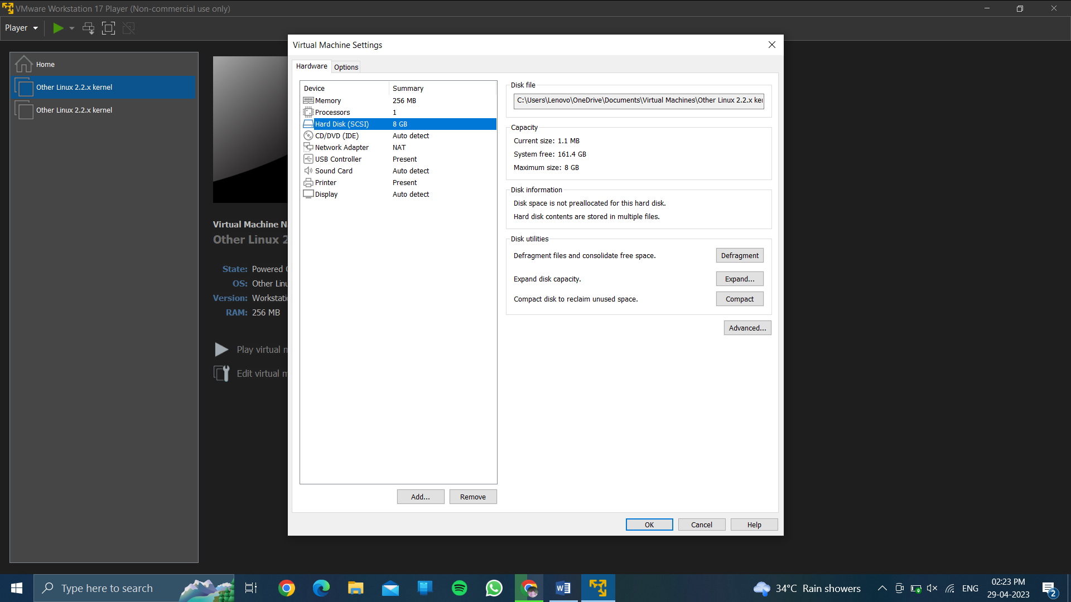

* **Then choose hard disk….**
* **Then click on add..**

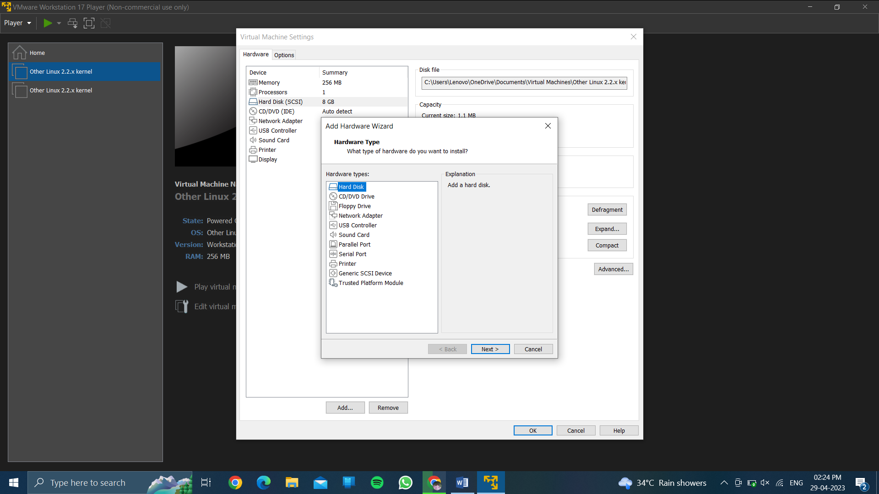

* **Choose hard disk…then next….**

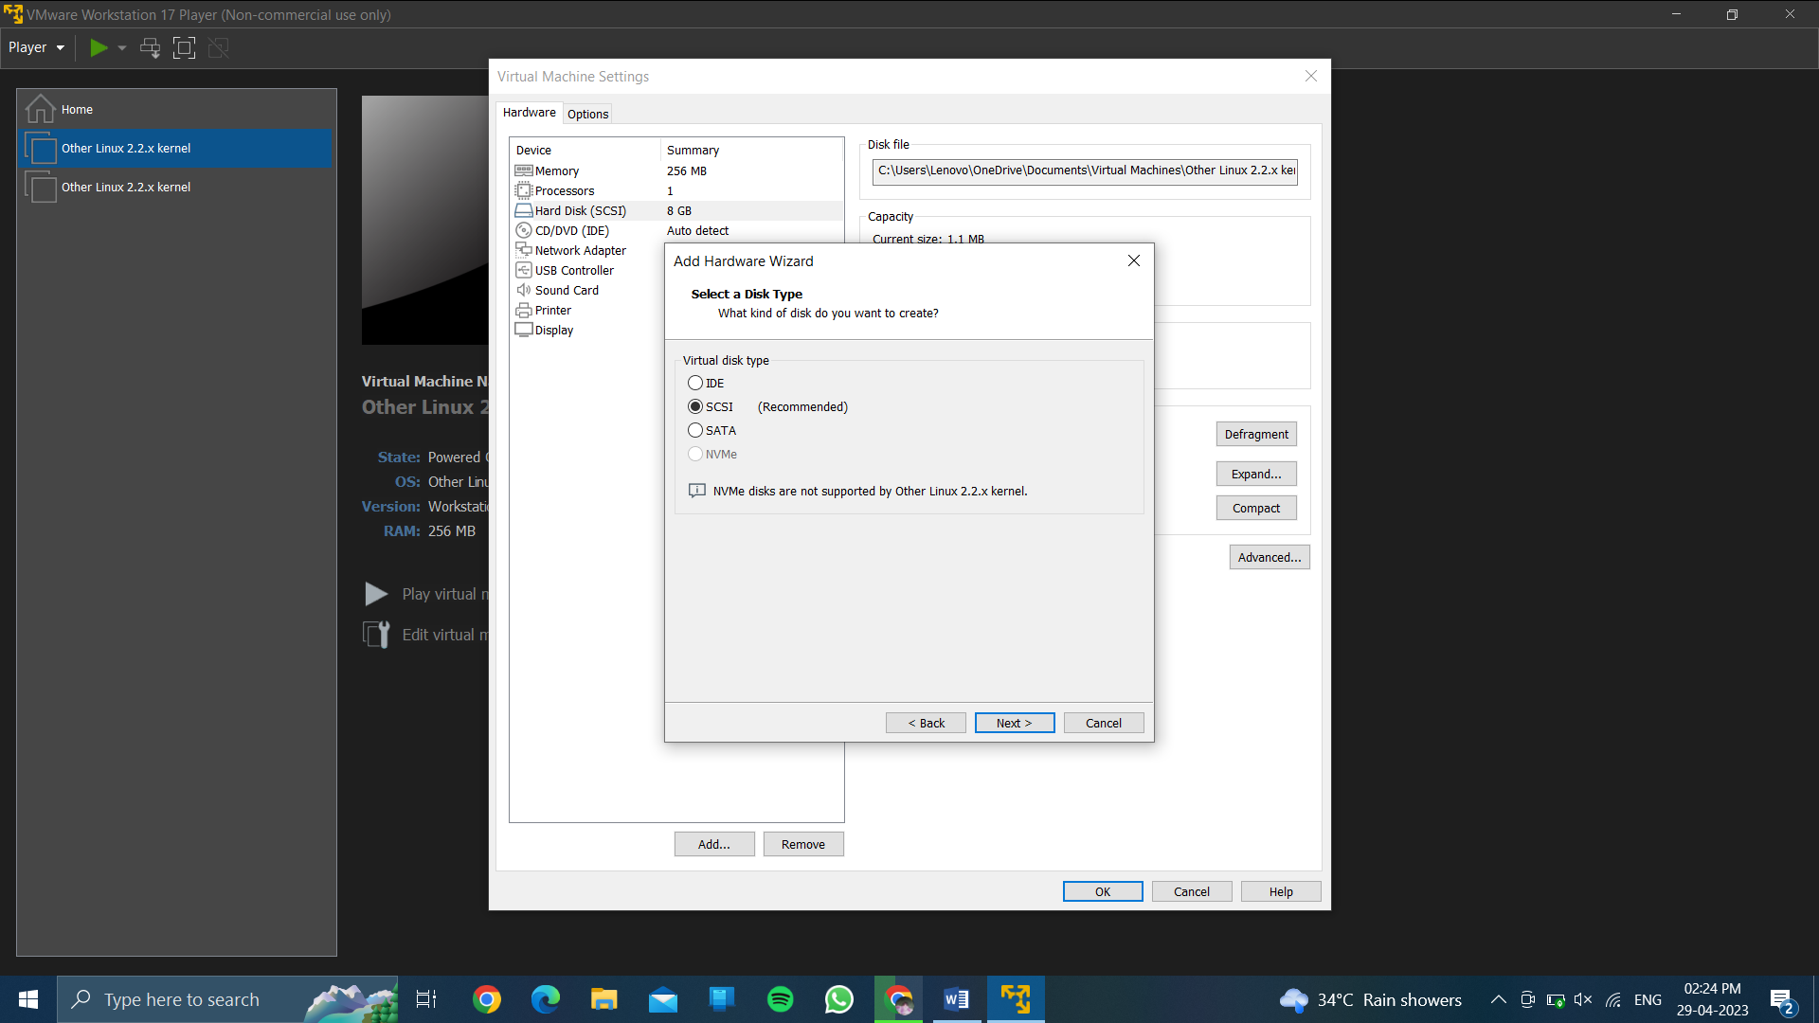

* **Then click on scsi …..then ..click next….**

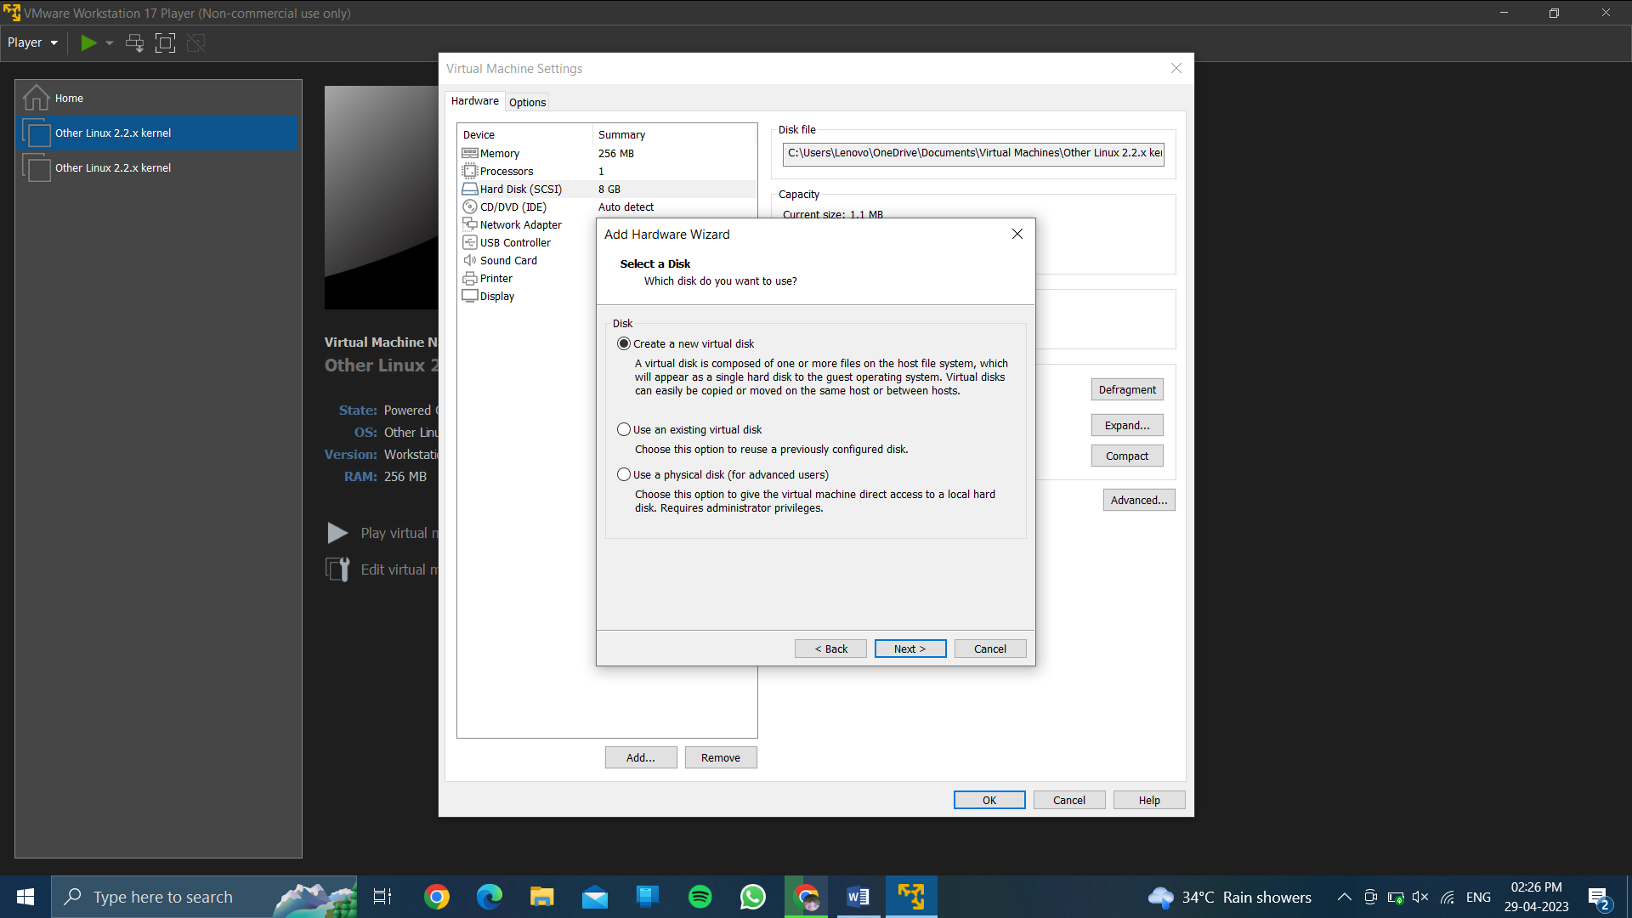

* **Choose create a new virtual disk…… then next…….**

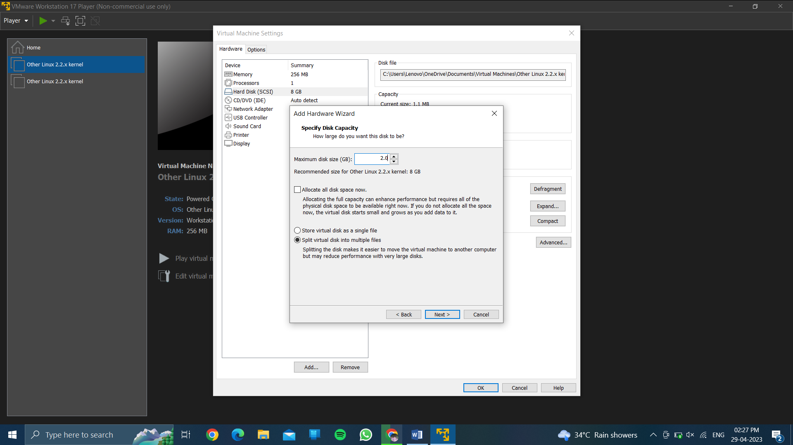

* **Then choose the size of memory…… then next……**

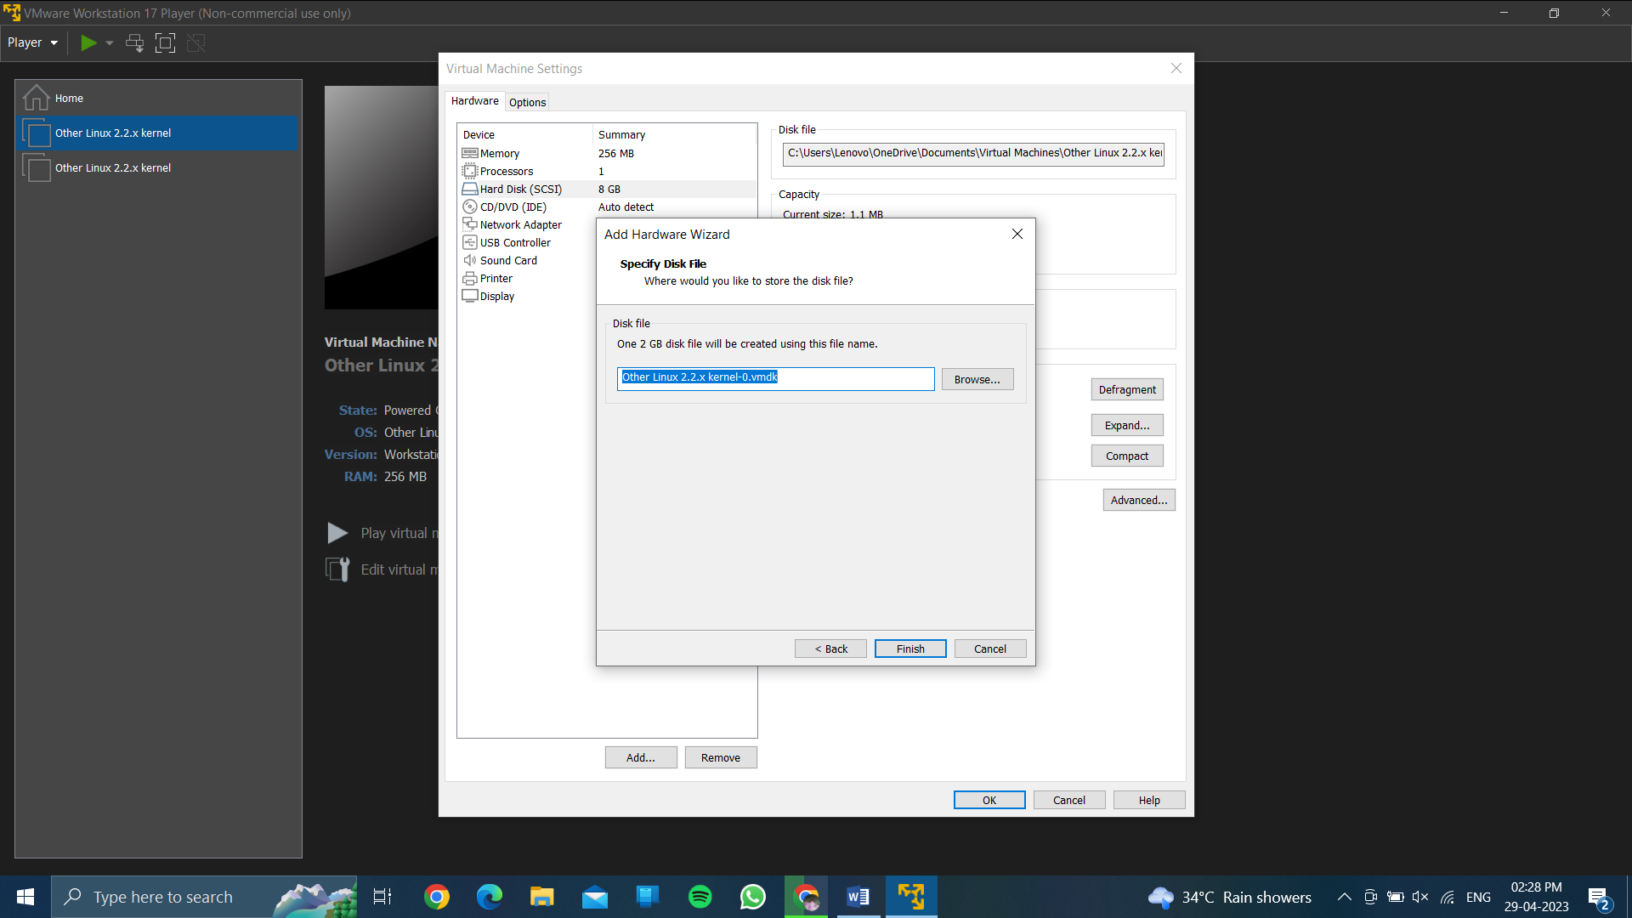

* **Then click on finish…..**

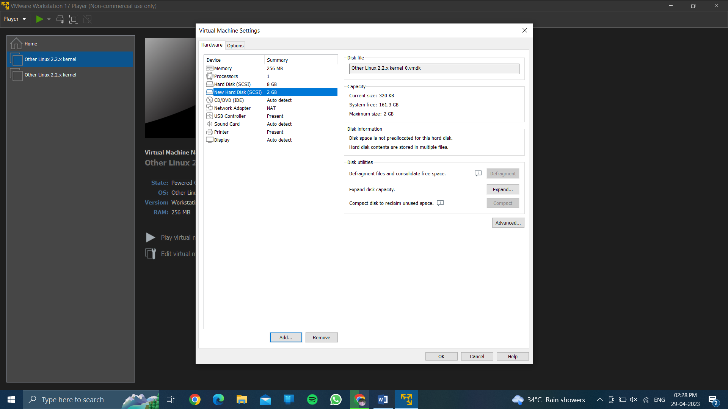

* **Then finally it will display the new harddisk with storage ………………**

**done.**